David L. Suddjian
Biological Consulting Services

801 Monterey Avenue, Capitola, CA 95010
Telephone 831· 479· 9603, email dsuddjian@aol.com

* DRAFT *

Summary of 2009
Marbled Murrelet Monitoring Surveys

In The Santa Cruz Mountains

Prepared for

Command Oil Spill Trustee Council

Prepared by

David L. Suddjian
Biological Consulting Services
801 Monterey Ave., Capitola, CA 95010

November 29, 2010
ABSTRACT

Monitoring of Marbled Murrelet activity using protocol-level audio-visual surveys continued in the Santa Cruz Mountains in 2009 at Big Basin Redwoods, Portola Redwoods, and Butano State Parks, and at San Mateo County Memorial Park. Murrelet activity decreased at all four parks, establishing new lows for all four parks individually and combined. Detections of below-canopy flights were very infrequent, suggesting a very low incidence of nesting. The period 2003-2009 had significant declining trends for both total detections and occupied site behaviors for all parks combined. Declining trends for the two areas with longer-term data sets – Big Basin Park (from 1995) and Peter’s Creek Bridge in Portola (from 1992) – continued to be highly significant. Corvid numbers recorded during murrelet surveys exhibited varied patterns of change. American Crows were again recorded at Big Basin and Memorial Parks during the murrelet nesting season in 2009, add for the first time at Portola. However, crows did not reside through the season in any park. Observations of raptors in the parks are described.

INTRODUCTION

This report presents the results of Marbled Murrelet (Brachyramphus marmoratus, hereafter referred to as “murrelet”) monitoring surveys conducted in 2009 for the Command Oil Spill Trustee Council (COSTC) in the Santa Cruz Mountains at Big Basin Redwoods State Park, Portola Redwoods State Park, Butano State Park, and San Mateo County Memorial Park (Figure 1). These surveys were commissioned to assist the COSTC in restoration planning for potential projects benefiting the murrelet.

Methods

Study Design

Dawn surveys were conducted at five stations in Big Basin, and at two stations each in Portola, Butano, and Memorial (Figure 1). Coverage at Butano, Memorial and one of the Portola stations was begun in 2003 to augment an existing long-term program of monitoring already established at Portola (since 1992) and Big Basin (since 1995). Since 2003 each station in each park has been surveyed three times annually from June to July, with two surveys at each in July. Two additional surveys are conducted at one of the Portola stations so that surveys occur there on three consecutive mornings in late June to continue a pattern of coverage begun at that station in 1992. Total annual surveys for each park are 15 at Big Basin, eight at Portola, and six each at Butano and Memorial.

Location of Survey Stations

Criteria for station placement and the selection of sites were described in Suddjian 2004.

The five stations at Big Basin (“Redwood Meadow”, “100 Acre Woods”, “Blooms Creek”, “Huckleberry”, and “Sempervirens”) were established in 1995 in a dispersed array in the upper watershed of the East Fork of Waddell Creek (Figure 2). “Redwood Meadow” station is at the meadow near the beginning of the Redwood Trail. “100 Acre Woods” station is on the North Escape Road at that road’s northern crossing of Opal Creek. “Blooms Creek” station is along East Ridge Trail east of Blooms Creek Campground. “Huckleberry” station is near site #13 in the tent cabins area of Huckleberry Campground. “Sempervirens” station is east of the Sempervirens Reservoir access road, midway between the reservoir and Sky Meadow Road Road.

At Portola (Figure 3) the “Peters Creek Bridge” station (established in 1992) is located on the bridge adjacent to the park’s main campground. “Iverson” station (established in 2003) is located where Iverson Trail crosses Pescadero Creek west of park headquarters (Figure 3).

At Butano (Figure 4), “Ben Ries” station (established in 2003) is on the main park road 50 meters before the road enters Ben Ries Campground, adjacent to campsite #1. “Little Butano Creek” station (established in 2003) is at a landslide along the park service road that begins at the entrance to the campground.

At Memorial (Figure 5), “Sequoia” station (established in 2003) is in the Sequoia Flat Campground where the main camp road enters the “D” section of the camp, adjacent to campsite #D6 (formerly named D1). “Memorial” station (established in 2003) is at Pescadero Creek adjacent to the Tan Oak Flat Picnic Area, at the site of the “swimming pool” that was formerly created seasonally in the creek.

Dawn Murrelet Surveys

Dawn murrelet surveys followed the standard protocol for audio-visual surveys in forests (Pacific Seabird Group 2003). David Suddjian conducted all the surveys. In addition to the murrelet survey data, all bird species detected were recorded (noting initial time, estimates of numbers, and other pertinent information), and two unlimited distance point counts were conducted during each dawn survey (Appendix 1). The point counts lasted 10 minutes and began at 0-5 minutes and 45 minutes after sunrise. Additional details of observations of Common Ravens (Corvus corax) and raptors (direction, distance, behavior, etc.), and a best estimate of the maximum number of Steller’s Jays (Cyanocitta stelleri) noted during each survey were also recorded.

Seasonal Timing of Coverage

Survey dates for each park in 2009 are given on Table 1. An effort was made to schedule coverage at each station on dates close to survey dates of previous years.

Additional Information on Murrelet Occurrence at Big Basin

Surveys at Redwood Meadow. Appendix 2 presents a summary of survey results from the Redwood Meadow / Park Headquarters parking lot of Big Basin. A total of 236 surveys following the same methods as those of this study have been completed at this site since 1991, representing the longest unbroken series of data for murrelets from any site in the Santa Cruz Mountains. This data set offers an opportunity to examine longer-term trends, and samples a broader part of the murrelet’s breeding season than do the June-July surveys conducted for the COSTC. In 2009 Suddjian conducted 11 additional surveys at the Redwood Meadow / Park Headquarters parking lot area from April 18 to July 19, in addition to the three for the COSTC contract.

Breeding Bird Survey Route. Appendix 3 presents a summary of results from a USGS Breeding Bird Survey (BBS) route sampled by Suddjian from 1992 to 2009 that begins at Big Basin. While the BBS method is not specifically designed for monitoring murrelets at forest sites, it does provide a repeated measure of activity, and coverage for the BBS at Big Basin was contemporaneous with the other monitoring efforts presented in this report.
Results

Marbled Murrelet

Dawn flight activity in 2009 is characterized below for each park. Subjective descriptors of “low, “moderate,” and “high” activity refer generally to total detection counts in the range of 0-10 detections, 11-50 detections, and >50 detections, respectively. Results of the 2009 murrelet surveys are shown on Table 1. Tables 2 and 3 compare annual average activity at each station and park.

Big Basin Redwoods State Park

Activity in 2009 reached a record low (Table 2, Figures 6 and 7). The 15 surveys produced only nine total detections, and no detections of below canopy flights. Nine surveys (60%). This was the first season on record in which no sub-canopy flights were observed on any surveys conducted for this monitoring program in Big Basin.

Activity at “Redwood Meadow” was low, with one or two detections recorded on each survey there (Table 1). This was the second year in a row with no sub-canopy flights recorded on the COSTC surveys at “Redwood Meadow.” However, single sub-canopy flights were recorded at Redwood Meadow on additional surveys conducted there beyond the scope of this study, but those extra surveys also recorded the lowest level of murrelet activity of any year (Appendix 2). The five detections recorded on the three COSTC surveys including birds passing over the station vicinity and birds circling in the area.

“100 Acre Woods” had no detections on any of the surveys (Table 1) for the first time in the history of this monitoring program.

“Huckleberry” had no detections on any of the surveys (Table 1) for the second year in a row, and the third time since this monitoring program began.

Activity at “Blooms Creek” was low, with 1-2 detections noted each survey (Table 1). Each of the four total detections was oriented west or northwest, including one of a bird that flew up the Blooms Creek drainage and then returned back to the west. None of the detections were closer than 150 meters to the station. No occupied site detections have been recorded at “Blooms Creek” since July 2001.

“Sempervirens” had no detections on any of the surveys (Table 1). There have been no detections on any of the 24 surveys at “Sempervirens” since activity was last noted there in July 2001.

Trends at Big Basin

Activity levels have remained relatively very low since 2002, following a major drop in activity from levels of the mid-1990s (Table 2; Figures 6 and 7). The average number of detections for all five stations combined was lower in 2009 than in any other year. The long-term decline was highly significant for total detections (r² = 0.808, p < 0.0001) and occupied site detections (r² = 0.682, p = 0.0005) (Figures 6 and 7). Each station individually exhibited the same general pattern of a decline from relative high activity in the beginning years of monitoring to relative low activity in recent years (Figure 8). Data collected in 2009 from the more extensive series of surveys at Redwood Meadow (Appendix 2) and from the BBS route (Appendix 3) continued to match the pattern of decline documented by this study.

Portola Redwoods State Park

Overall activity at Portola in 2009 was the lowest recorded since this study began (Table 2, Figure 11). As first happened in 2008, two surveys in 2009 had zero detections (Table 2). 2009 was the first year that no occupied-site behaviors were recorded in this park
The number of occupied site behaviors was very low, with just a single sub-canopy flight observed (Figure 12).

Activity at “Peters Creek Bridge” was low (2-8 detections; Table 1). A lack of any sub-canopy flights marked the first time such behavior was not noted at this station since monitoring began in 1992. Patterns of activity around the station were similar to prior years, with detections in varied directions and extensive circling over the area.

Activity at “Iverson” was low to moderate (0-15 detections), with a single detection of a below canopy flight on one survey (Table 1). This was of two murrelets flying low over Pescadero Creek. The relatively low level of activity contrasted strongly with that noted in 2003 and 2004 (Suddjian 2004 and 2005a), when activity at “Iverson” had been among the highest of any station in this study, but was similar to activity levels from 2005-2008 (Table 2, Figure 13).

Trends at Portola

Three Consecutive June Mornings at Peters Creek Bridge. The only long term comparison available for Portola is for the surveys conducted on three consecutive mornings in late June at “Peters Creek Bridge” (Table 3). Activity in 2009 was the lowest ever noted (Table 3, Figure 9). Linear regression on average total detections over the whole period of 1992-2009 showed a significant declining trend (r² = 0.495, P = 0.002; Figure 10). The declining trend for occupied site detections was marginally significant over the whole period of 1992-2009 (r² = 0.225, P = 0.040), and was highly significant from 1995 onwards (r² = 0.684, P < 0.001).

Entire Season for Both Stations. The seven-year period 2003-2009 showed a significant decline in total detections (r² = 0.661, P = 0.013), and a significant decline in occupied site detections (r² = 0.588, P = 0.022). The decrease is shown on Figures 11 and 12.

Butano State Park

Overall activity at Butano in 2009 was the lowest of any year of this study (Table 2, Figures 11 and 13). The number of occupied site behaviors also decreased to a new low for the seven years of surveys (Table 2, Figure 12).

Activity at “Ben Ries” ranged from low to barely moderate (0-11 detections), with no below canopy flight recorded in 2009 (Table 1). As in prior years, most flight activity was oriented toward Little Butano Creek or up the canyon to the east, and included detections of birds moving up or down the drainage. There were also a small number of detections close to the station and over the adjacent campground.

Activity at “Little Butano Creek” ranged from low to moderate (3-34 detections), with three occupied site detections noted on two of the three surveys (Table 1). Activity at this station averaged the highest for any station in the study for the fifth year in a row, with 34 detections on July 20 being the most recorded on any survey in 2009. As in prior years, each survey recorded extensive movement by murrelets flying up and down the drainage, and circling over the canyon in the vicinity of the station, and upstream of the station.

Trends at Butano

The seven-year period 2003-2009 showed a marginally significant decline for total detections (r² = 0.415, P = 0.059), but the decline in occupied site detections was not significant (Figures 11 and 12).

San Mateo County Memorial Park

Overall activity at Memorial Park in 2009 was the lowest recorded on any year of this study (Table 2, Figures 11 and 13). There were no occupied site detections (Table 1, Figure 12).

“Memorial” had very low activity, with two detections on one survey (Table 1).

“Sequoia” had three detections on two surveys and none on one surveyhen low activity July 25 just (one detection; Table 1).

Trends at Memorial

The trend for the seven-year period of 2003-2009 was marginally significant for both total detections (r² = 0.327, P = 0.090) and occupied site detections (r² = 0.415, P = 0.058) (Figures 11 and 12).

CORVIDS

Counts of Steller’s Jay and Common Raven from the dawn surveys at each station are given on Table 4. General summaries of numbers and activities around the murrelet survey station are given below. American Crows (Corvus brachyhrynchos) were detected in 2009 on four occasions at Big Basin, once at Portola, and twice at Memorial Park. These are detailed below under the headings for the respective parks.

Big Basin Redwoods State Park

Steller’s Jay

Steller’s Jay was detected on all surveys at all stations. The pattern of relative abundance among stations closely matched that of prior years, with highest abundance correlated with the proximity to campgrounds (Table 4). Overall jay abundance recorded during the murrelet surveys at Big Basin was reduced d from 2008, slightly less than the previous lowest year (Figure 14a). Most of the decrease in 2009 was due to reduced numbers at Huckleberry Campground.

Common Raven

Common Raven was detected on nine of 15 surveys, and was detected at all five stations. Counts ranged from 0-5 per station (Table 4). Overall raven abundance recorded during the murrelet surveys at Big Basin was similar to that of 2008 (Figure 15a). Territorial pairs resided near each of the stations where the species was recorded. Nesting productivity was moderate to less than average.

American Crow

Detections of American Crows in Big Basin in 2009 included one at Blooms Creek Campground on June 4, two flying west at Slippery Rock on June 19, one near the intersection of North China Grade and Highway 236 on July 4, and one at the east end of Gazos Creek Road near the day use picnic area on July 18. There was no indication of any resident crows in the interior region of the park during the 2009 breeding season.

Portola Redwoods State Park

Steller’s Jay

Steller’s Jay was detected on all surveys at both stations, with more tallied at “Peters Creek Bridge” (at the edge of the campground) than at “Iverson” (Table 4). Overall jay abundance recorded during the murrelet surveys at Portola was down slightly from 2008, but was similar to that of prior years (Figure 14a).

Common Raven

Ravens were irregularly noted during the murrelet surveys at Portola in 2009, with all detections possibly involving members of just one pair. No nesting evidence was observed in the region of the survey stations.

American Crow

Detections of American Crows in Portola in 2009 included one in the Evans Creek watershed (northwest of the main campground) on May 28. Two were about one mile north of the park along Portola State Park Road on June 23. These were the first reported detections of this species in and immediately near this park.

Butano State Park

Steller’s Jay

Steller’s Jay was detected on all surveys at both stations, with similar numbers at each (Table 4). Overall jay abundance recorded during the murrelet surveys increased in 2009 (Figure 14a).

Common Raven

A pair of ravens resided in the area of Ben Reis Campground and nested a short way north of the campground, fledging two young in July. This was the same territory as had been occupied in other recent years. A raven was detected from the Little Butano Creek station on just one survey

San Mateo County Memorial Park

Steller’s Jay

Steller’s Jay was detected on all surveys at both stations, with higher numbers at Sequoia Flat (Table 4). Jay abundance decreased in 2009, and was near to the previous low year of 2006. Jays remained more abundant at Memorial County Park than the other parks (Figure 14).

Common Raven

Common Ravens were encountered on each survey at both stations in 2009 (Table 4). Raven numbers recorded during the dawn surveys were mostly similar to 2008, but the average shown in Figure 15 was elevated by a flock of seven “non-local” ravens detected on June 12. Few pairs nested in or near the park, and fledgling success below average.

American Crow

Detections of American Crows in Memorial Park in 2009 included one near Homestead Flat Group Campground on May 29, and one at Sequoia Flat Campground on July 8. the species was first recorded in the park in 2008. There was no suggestion that the species was resident in or near the park in 2009.

RAPTORS

Big Basin Redwoods State Park

Cooper’s Hawks (A. cooperi) nested again near Slippery Rock. A family group of three juveniles was begging there on August 8. An adult called north of Sempervirens Reservoir on July 5.

Red-shouldered Hawk (Buteo lineatus) was detected on about 12 tim in June and July, a slight decrease from 2008, and still notably down from the 24 detections in 2007. It was recorded at three of the five murrelet survey stations (“100 Acre Woods”, “Huckleberry” and “Sempervirens.” Extensive field surveys by Suddjian for this study and other research in the park produced an estimate of three to four breeding pairs in the East Fork Waddell watershed in 2009, similar to 2008, but down from nine in 2007 and seven in 2006.

Barn Owl (Tyto alba), Western Screech-Owl (Megascops kennicottii), Northern Pygmy-Owl (Glaucidium gnoma), Great Horned Owl and Northern Saw-whet Owl (Aegolius acadicus) were heard in the study area this year. The Great Horned Owl detections were of note, as this species had not been recorded in the area of the murrelet survey stations in any prior year of this study. But in 2009 a male was calling east of “Huckleberry” on June 16, and a female was giving food solicitation calls near there on July 7, suggesting a pair was on territory and may have nested in that area.

Portola Redwoods State Park

At least two pairs Red-shouldered Hawks resided in the area of the park visited for the murrelet surveys. One pair (or two) continued in the area from vicinity of “Iverson” to Evans Creek. Another pair was again to the east in the vicinity of the Iverson Cabin site. No nesting evidence was obtained. Additional individuals were noted in the park well away from the murrelet survey areas.

Western Screech-Owl, Northern Pygmy-Owl and Northern Saw-whet Owl were noted in the study area.

Butano State Park

After two successful years of nesting near Ben Ries Campground, Sharp-shinned Hawks were not recorded in the park this season.

A pair of Red-shouldered Hawks continued to reside in the general region of Ben Ries Campground.

Western Screech-Owl, Northern Pygmy-Owl and Northern Saw-whet Owl were heard in the study area in 2009. A pair of Great Horned Owls nested near the park entry, not far from Cloverdale Road.

San Mateo County Memorial Park

Peregrine Falcon continued absent at Memorial Park, after being present from 2005-2007.

Red-shouldered Hawks continued to be regularly noted in and adjacent to Memorial Park in 2009, although detections were less frequent than in prior years. There were at least two or three pairs at this park and surroundings in June and July.

Barn Owl and Western Screech-Owl were recorded in the study area in 2009.

Discussion

In 2009 overall Marbled Murrelet activity decreased at all four parks, and established new lows for all four parks (Figure 16).Detections of below-canopy flights, of the greatest interest as indicators of likely nesting behavior, remained very infrequent.

Butano had the highest average flight activity in 2009; this park has had the highest average activity in six years of the seven years of monitoring (Figure 11). Portola had the next highest level of activity, but as in 2008 there were surveys that recorded zero detections. Memorial and Big Basin, each similarly low in activity, again ranked in third and fourth place, respectively (Figure 11). 2009 was the first year that Big Basin ranked last among the four parks in murrelet activity.

When data from all four parks was pooled, the seven-year period had significant declining trends for both total detections (r² = 0.734, p = 0.007) and occupied site behaviors (r² = 0.693, p = 0.010). Declining trends for the two areas with longer-term data sets – Big Basin Park and Peter’s Creek Bridge in Portola – continued to be highly significant, and significant negative trends were evident for the first time at both Butano and Memorial parks.

Literature Cited

Nelson, S. K. 1997. Marbled Murrelet (Brachyramphus marmoratus). No. 276 in The birds of North America (A. Poole and F. Gill, Eds.) Acad. Of Nat. Sci., Philadelphia, Pennsylvania, and the Amer. Orn. Union, Washington D.C.

Pacific Seabird Group. 2003. Methods for surveying Marbled Murrelets in forests: a revised protocol for land management and research. Marbled Murrelet Technical Committee. Unpubl. report dated 6 January, 2003.

Suddjian, D. L. 2001. 2001 Marbled Murrelet Monitoring Surveys at Big Basin and Portola State Parks. Unpubl. report. Prepared for the California Dept. of Fish and Game.

Suddjian, D. L. 2003a. Summary of 2002 Marbled Murrelet monitoring surveys
at Big Basin and Portola State Parks. Unpubl. report. Prepared for the California Dept. of Fish and Game.

Suddjian, D. L. 2003b. Summary of 2003 Department of Fish and Game Marbled Murrelet Monitoring Surveys At Big Basin and Portola Redwoods State Parks Unpubl. report prepared for the California Dept. of Fish and Game.

Suddjian, D. L. 2004. Summary of 2003 Marbled Murrelet Surveys in the Santa Cruz Mountains. Unpubl. report prepared for Command Oil Spill Trustee Council.

Suddjian, D. L. 2005a. Summary of 2004 Marbled Murrelet Surveys in the Santa Cruz Mountains. Unpubl. report prepared for Command Oil Spill Trustee Council.

Suddjian D. L. 2005b. Summary of 2004 Corvid Monitoring Surveys in the Santa Cruz Mountains. Unpubl. report prepared for Command Oil Spill Trustee Council.

Suddjian, D. L. 2005c. Summary of 2005 Marbled Murrelet Surveys in the Santa Cruz Mountains. Unpubl. report prepared for Command Oil Spill Trustee Council.

Suddjian, D. L. 2008a. Summary of 2006 Marbled Murrelet Surveys in the Santa Cruz Mountains. Unpubl. report prepared for Command Oil Spill Trustee Council.

Suddjian, D. L. 2008b. Summary of 2007 Marbled Murrelet Surveys in the Santa Cruz Mountains. Unpubl. report prepared for Command Oil Spill Trustee Council.

Suddjian, D. L. 2009. Summary of 2008 Marbled Murrelet Surveys in the Santa Cruz Mountains. Unpubl. report prepared for Command Oil Spill Trustee Council.
Table 1. Summary of dawn murrelet surveys conducted at each park in 2009.

Station Date Obs. Cloud Precip. Total # OB¹
Cover # Dets. Dets.

Big Basin

Redwood Meadow 17 June 09 DLS 50-100% Fog 0 0
Redwood Meadow 3 July 09 DLS 0% None 2 0
Redwood Meadow 14 July 09 DLS 0% None 2 0

100 Acre Woods 15 June 09 DLS 20-50% None 0 0
100 Acre Woods 4 July 09 DLS 100% Fog 0 0
100 Acre Woods 15 July 09 DLS 0% None 0 0

Blooms Creek 18 June 09 DLS 0% None 1 0
Blooms Creek 7 July 09 DLS 0% None 1 0
Blooms Creek 17 July 09 DLS 0% None 2 0

Huckleberry 16 June 09 DLS 100% Fog 0 0
Huckleberry 6 July 09 DLS 0% None 0 0
Huckleberry 18 July 09 DLS 0% None 0 0

Sempervirens 19 June 09 DLS 100% Fog 0 0
Sempervirens 5 July 09 DLS 0% None 0 0
Sempervirens 16 July 09 DLS 0% None 0 0

Portola

Iverson 23 June 09 DLS 0% None 0 0
Iverson 10 July 09 DLS 100% Fog 14 1
Iverson 28 July 09 DLS 100% Fog 15 0

Peters Creek Bridge 24 June 09 DLS 0-100% Fog. 6 0
Peters Creek Bridge 25 June 09² DLS 100% Fog 2 0
Peters Creek Bridge 26 June 09² DLS 100% Fog 6 0
Peters Creek Bridge 9 July 09 DLS 100% Fog 8 1
Peters Creek Bridge 27 July 09 DLS 0% None 5 0

Table 1, continued

Station Date Obs. Cloud Precip. Total # OB¹
Cover # Dets. Dets.

Butano

Ben Ries 11 June 09 DLS 100% Fog 0 0
Ben Ries 1 July 09 DLS 20-100% Non/Fog 5 0
Ben Ries 21 July 09 DLS 100% Fog 11 0

Little Butano Creek 10 June 09 DLS 100% Fog/Driz 3 0
Little Butano Creek 2 July 09 DLS 100% Fog 16 3
Little Butano Creek 20 July 09 DLS 0-100% None/Fog 34 3

Memorial

Memorial 13 June 09 DLS 100% Fog 0 0
Memorial 11 July 09 DLS 0-100% Fog/None 0 0
Memorial 23 July 09 DLS 100% Fog 2 0

Sequoia 12 June 09 DLS 100% Fog 3 0
Sequoia 8 July 09 DLS 0-100% Fog/None 3 0
Sequoia 22 July 09 DLS 100% Fog 0 0

- OB = detections with “occupied site” behavior (i.e., below canopy flight or tree interactions).
- Two extra surveys were done at Peters Creek Bridge as part of the annual monitoring pattern established for this station.

Table 2. Comparison of murrelet activity levels between years at each park from 1995-2009.¹

All Detections Occupied Site Detections
Station Year N Avg # S.D. Avg # S.D.
Dets. Dets.

Big Basin

Redwood Meadow 1995 4 177.0 102.3 64.0 69.5
1996 4 97.0 19.0 27.5 11.6
1998 4 92.3 54.0 33.5 31.8
2001 3 86.3 125.5 8.0 7.0
2002 3 18.7 15.9 1.3 1.5
2003 3 16.3 5.7 1.3 1.5
2004 3 17.0 14.0 2.3 0.6
2005 3 14.0 6.1 1.3 1.5
2006 3 18.3 9.7 9.0 5.2
2007 3 16.3 11.0 2.7 2.3
2008 3 12.0 8.7 0.0 0.0
2009 3 1.7 0.6 0.0 0.0

100 Acre Woods 1995 4 25.3 20.7 9.0 9.4
1996 4 9.5 7.1 2.0 2.4
1998 4 5.0 4.4 3.7 3.5
2001 3 3.7 4.6 0.3 0.6
2002 3 2.7 4.6 0.0 0.0
2003 3 7.0 11.3 2.3 4.5
2004 3 7.0 10.4 0.0 0.0
2005 3 1.0 1.7 0.0 0.0
2006 3 8.0 11.1 3.0 5.2
2007 3 3.0 5.2 0.0 0.0
2008 3 6.7 11.5 2.3 4.0
2009 3 0.0 0.0 0.0 0.0

Blooms Creek 1995 4 44.8 42.5 1.5 2.4
1996 4 44.8 27.0 1.8 2.2
1998 4 15.0 14.5 1.0 1.4
2001 3 23.0 4.4 3.0 5.2
2002 3 0.7 1.2 0.0 0.0
2003 3 2.7 1.5 0.0 0.0
2004 3 1.3 1.5 0.0 0.0
2005 3 4.0 3.0 0.0 0.0
2006 3 3.0 4.4 0.0 0.0
2007 3 2.3 3.2 0.0 0.0
2008 3 1.3 1.5 0.0 0.0
2009 3 1.3 0.6 0.0 0.0

Table 2, continued.

All Detections Occupied Site Detections
Station Year N Avg # S.D. Avg # S.D.
Dets. Dets.

Big Basin, continued

Huckleberry 1995 4 24.3 18.1 7.5 9.3
1996 4 23.3 25.1 5.5 9.7
1998 4 14.0 9.9 1.0 0.8
2001 3 4.3 3.8 0.0 0.0
2002 3 0.0 0.0 0.0 0.0
2003 3 3.0 2.6 0.7 1.2
2004 3 0.3 0.6 0.0 0.0
2005 3 1.0 1.7 0.0 0.0
2006 3 6.0 3.5 0.3 0.6
2007 3 2.0 1.0 0.7 0.6
2008 3 0.0 0.0 0.0 0.0
2009 3 0.0 0.0 0.0 0.0

Sempervirens 1995 4 1.3 1.9 0.3 0.5
1996 4 4.8 7.5 0.0 0.0
1998 4 5.3 8.6 0.3 0.5
2001 3 1.0 1.7 0.0 0.0
2002 3 0.0 0.0 0.0 0.0
2003 3 0.0 0.0 0.0 0.0
2004 3 0.0 0.0 0.0 0.0
2005 3 0.0 0.0 0.0 0.0
2006 3 0.0 0.0 0.0 0.0
2007 3 0.0 0.0 0.0 0.0
2008 3 0.0 0.0 0.0 0.0
2009 3 0.0 0.0 0.0 0.0

All Big Basin 1995 20 54.5 78.8 16.5 37.4
Stations Combined 1996 20 35.9 38.4 7.4 12.2
1998 20 27.4 41.9 8.1 18.8
2001 15 23.7 58.1 2.3 4.6
2002 15 4.4 9.7 0.3 0.8
2003 15 5.8 7.7 0.9 1.9
2004 15 5.1 9.4 0.5 1.0
2005 15 4.0 6.0 0.3 0.8
2006 15 7.1 8.8 2.5 4.5
2007 15 4.7 7.7 1.9 1.4
2008 15 4.0 7.3 0.5 1.8
2009 15 0.6 0.8 0.0 0.0

Table 2, continued.

All Detections Occupied Site Detections
Station Year N Avg # S.D. Avg # S.D.
Dets. Dets.

Portola

Peters Creek Bridge 2003 5 33.2 16.9 6.0 6.4
2004 5 35.6 22.2 4.4 3.4
2005 5 18.0 5.9 0.2 0.4
2006 5 18.6 4.2 2.4 1.8
2007 5 30.6 14.7 0.8 0.8
2008 5 19.0 11.4 0.6 0.9
2009 5 5.4 2.2 0.0 0.0

Iverson 2003 3 59.3 18.6 28.3 10.7
2004 3 39.3 13.6 9.0 5.3
2005 3 3.7 3.1 0.0 0.0
2006 3 11.7 9.1 1.7 2.9
2007 3 8.7 2.5 0.7 1.2
2008 3 12.7 11.2 2.7 2.5
2009 3 9.7 9.4 0.3 0.6

All Portola 2003 8 43.0 21.1 14.4 13.8
Stations Combined 2004 8 37.0 18.4 6.1 4.5
2005 8 12.6 8.8 0.1 0.4
2006 8 16.0 6.8 2.1 2.1
2007 8 22.4 16.0 0.8 0.9
2008 8 16.6 11.0 1.4 1.9
2009 8 7.0 5.3 0.1 0.4

Butano

Ben Ries 2003 3 23.3 19.0 1.3 2.3
2004 3 48.0 34.0 5.7 6.0
2005 3 13.7 11.9 0.0 0.0
2006 3 11.7 9.6 0.7 1.2
2007 3 12.7 11.7 0.3 0.6
2008 3 10.0 4.4 0.0 0.0
2009 3 5.3 5.5 0.0 0.0

Little Butano Creek 2003 3 34.0 8.2 6.0 8.7
2004 3 68.3 40.4 22.0 14.4
2005 3 26.7 2.5 4.0 5.3
2006 3 48.0 29.9 4.3 4.5
2007 3 46.3 35.6 5.7 3.2
2008 3 20.7 7.6 3.0 3.6
2009 3 17.7 15.6 2.0 1.7

Table 2, continued.

All Detections Occupied Site Detections
Station Year N Avg # S.D. Avg # S.D.
Dets. Dets.

All Butano 2003 6 28.7 14.3 3.7 6.2
Stations Combined 2004 6 58.2 35.2 13.8 13.3
2005 6 20.2 10.5 2.0 4.0
2006 6 29.8 28.1 2.5 3.6
2007 6 29.5 30.0 3.0 3.6
2008 6 15.3 8.1 1.5 2.8
2009 6 11.5 12.4 1.0 1.6

Memorial

Memorial 2003 3 4.3 6.7 0.0 0.0
2004 3 1.0 1.7 0.0 0.0
2005 3 1.3 1.5 0.0 0.0
2006 3 4.7 5.7 0.3 0.6
2007 3 0.7 1.2 0.0 0.0
2008 3 0.7 0.6 0.0 0.0
2009 3 0.7 1.2 0.0 0.0

Sequoia 2003 3 9.7 7.4 0.7 1.2
2004 3 12.3 7.6 1.0 1.0
2005 3 15.3 15.0 0.0 0.0
2006 3 13.7 8.6 0.0 0.0
2007 3 8.7 9.6 0.3 0.6
2008 3 7.0 11.3 0.3 0.6
2009 3 2.0 1.7 0.0 0.0

All Memorial 2003 6 7.0 6.9 0.3 0.8
Stations Combined 2004 6 6.7 7.9 0.5 0.8
2005 6 15.3 15.0 0.0 0.0
2006 6 9.2 8.8 0.2 0.4
2007 6 4.7 7.5 0.2 0.4
2008 6 3.8 7.9 0.2 0.4
2009 3 1.3 1.5 0.0 0.0

1. This table only presents data from CDFG or COSTC sponsored surveys. Results from additional non-CDFG or COSTC sponsored surveys are not shown.

Table 3. Average annual murrelet activity on the three consecutive dawn surveys at “Peters Creek Bridge” station in Portola Redwoods State Park, 1992-2009.¹

All Detections Occupied Site Detections
Station Year N Avg # S.D. Avg # S.D.
Dets. Dets.

Peters Creek Bridge 1992 3 40.7 12.1 4.0 2.6
1993 3 71.3 7.6 3.0 2.6
1994 3 167.3 36.1 8.0 2.0
1995 3 80.0 19.1 17.3 20.5

1998 3 73.7 22.3 18.0 16.5

2001 3 79.0 22.3 19.7 18.8
2002 3 32.3 1.2 2.7 1.5
2003 3 21.3 6.5 1.3 0.6
2004 3 25.3 3.2 2.0 1.0
2005 3 20.3 6.0 0.3 0.6
2006 3 18.0 2.0 2.7 1.5
2007 3 23.7 10.5 0.7 1.2
2008 3 26.0 1.7 0.7 1.2
2009 3 4.7 2.3 0.0 0.0

1. Only data from the surveys on three consecutive mornings in late June or very early July is shown. There is no data available for 1996, 1997, 1999, or 2000.
Table 4. High counts for Steller’s Jay and Common Raven from 10-minute point counts and 2-hour dawn surveys at each park in 2009.

Steller’s Jay Common Raven
Point 2-hour Point 2-hour
Counts Survey Counts Survey

Big Basin
Redwood Meadow 4 7 2 4
100 Acre Woods 2 4 2 2
Bloom’s Creek 6 8 3 5
Huckleberry 19 19 1 1
Sempervirens 3 5 2 2

Portola
Peters Creek Bridge 4 5 --¹ 2
Iverson 3 4 1 1

Butano
Ben Ries 7 7 3 4
Little Butano Creek 3 6 --¹ 1

Memorial
Memorial 8 8 2 4
Sequoia 14 15 5 11²

1. A raven was recorded during the surveys, but not during the 10-min. point counts.
2. Tally of 11 includes 7 “non-local” ravens moving through area
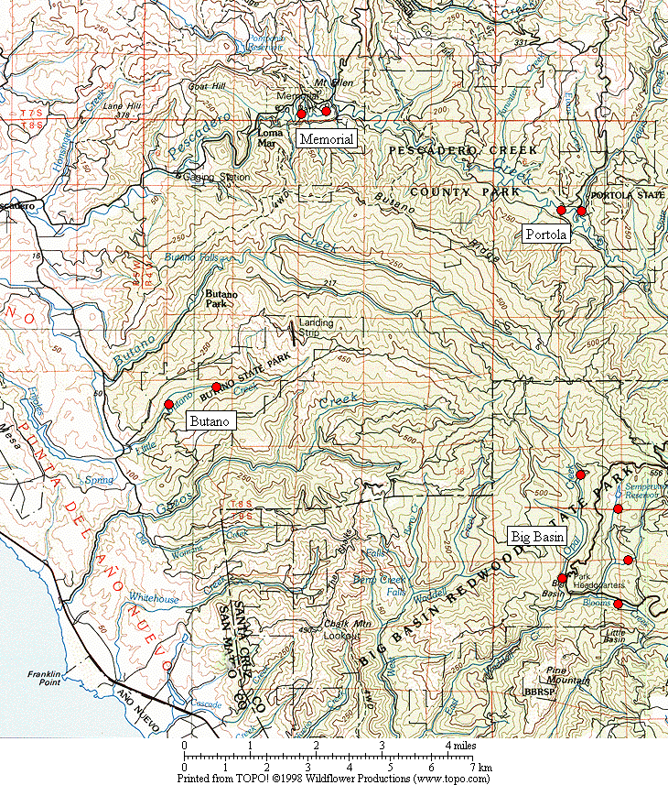

Figure 1. General location of the Marbled Murrelet monitoring stations in the four Santa Cruz Mountains parks.

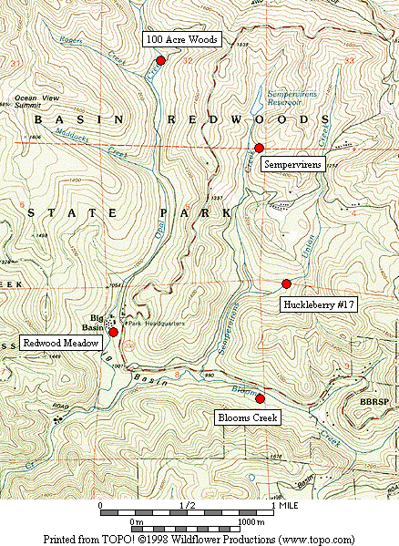

Figure 2. Location of Marbled Murrelet monitoring stations in Big Basin Redwoods State Park.

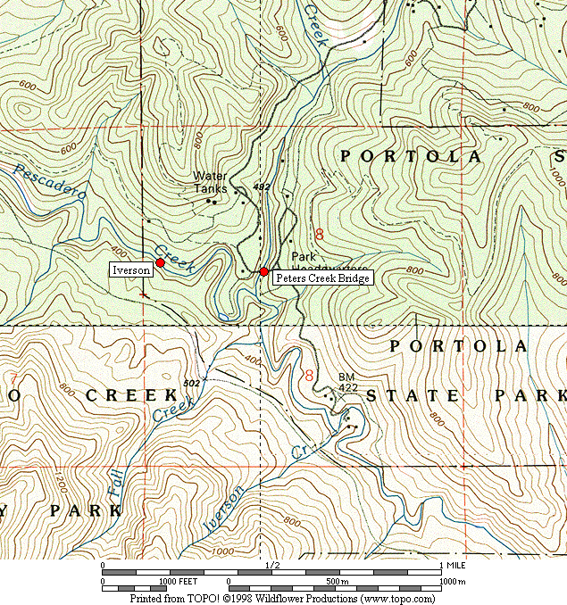

Figure 3. Location of Marbled Murrelet monitoring stations in Portola Redwoods State Park.

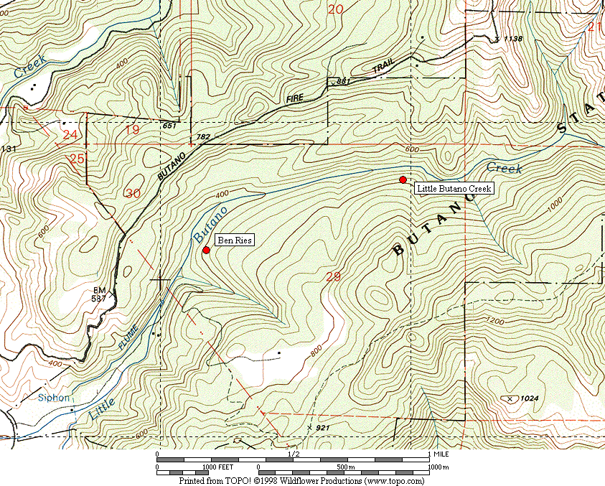

Figure 4. Location of Marbled Murrelet monitoring stations in Butano State Park.

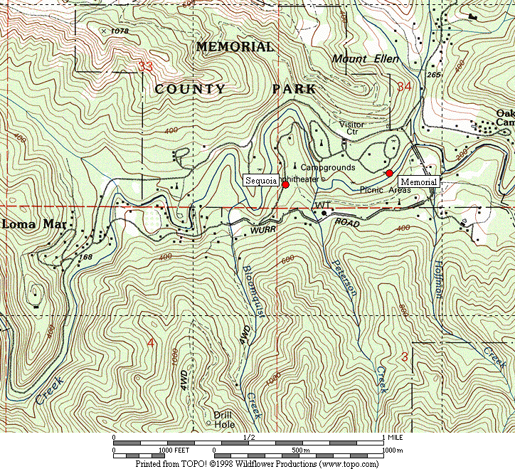

Figure 5. Location of Marbled Murrelet monitoring stations in San Mateo County Memorial Park.

Figure 6. Average murrelet activity on dawn surveys from all five Big Basin stations, 1995-2009. (Note: no data from 1997, 1999 or 2000.)

Figure 7. Average annual murrelet activity at all five Big Basin stations, showing total detections with polynomial regression trend, 1995-2009. (Note: no data from 1997, 1999 or 2000.)
A. “Redwood Meadow” B. “100 Acre Woods” (Note: no
detections were recorded in 2009)

C. “Blooms Creek” D. “Huckleberry” (Note: no
detections were recorded in 2002, 2008, or 2009)
E. “Sempervirens” (Note: no detections
were recorded from 2002 to 2009)

Figure 8. Annual activity levels (average total detections) at individual Big Basin monitoring stations from 1995 – 2009. (Note: no data for 1997, 1999 or 2000. See table 2 for standard deviations)
Figure 9. Average detections from dawn surveys on three consecutive mornings in late June or early July at “Peters Creek Bridge,” Portola Redwoods State Park, 1992-2009. (Note: no data from 1996, 1997, 1999, or 2000.)

Figure 10. Linear regression on average detections from dawn surveys on three consecutive mornings at “Peters Creek Bridge” in Portola Redwoods State Park, 1992 to 2009. (Note: no data from 1996, 1997, 1999, or 2000.)

Figure 11. Relative levels of Marbled Murrelet activity at each park in 2003 to 2009 using total detections.

Figure 12. Relative levels of Marbled Murrelet activity at each park in 2003 to 2009 using detections with occupied site behavior.

A. “Peters Creek Bridge”, Portola B. “Iverson”, Portola C. “Ben Ries”, Butano

D. “Little Butano Creek”, Butano E. “Memorial”, Memorial F. “Sequoia”, Memorial

Figure 13. Annual activity levels (average total detections) at individual monitoring stations from 2003-2009 at Portola, Butano and Memorial parks. (Note: scales for the y-axis vary; see table 2 for standard deviations)
32
- Individual Parks

- All Parks Combined

Figure 14. Average number of Steller’s Jays (A) per station in each park 2001-2009, and (B) in all parks combined 2003-2009. (Notes: Data from dawn murrelet surveys, using maximum count per year for each station. Jay numbers from 10-minute point counts. Only Big Basin stations were surveyed in 2001-2002).

A. Individual Parks

B. All Parks Combined

Figure 15. Average number of Common Ravens (A) per station in each park 2001-2009, and (B) in all parks combined 2003-2009. (Notes: Data from dawn murrelet surveys, using maximum count per year for each station. Raven numbers from 2-hour surveys. Only Big Basin stations were surveyed in 2001-2002).

Figure 16. Average number of Marbled Murrelet detections for all parks combined in 2003-2009.
Appendix 1. Still To Be Updated Bird species detected and point count maxima from 2009 dawn Marbled Murrelet surveys. (See footnote for key to station codes.)¹

Big Basin Portola Butano Memorial

Species RM BC HU OA SP PC IV BR LB ME SQ

Wood Duck – – – – – – 1 – – X² –
Common Merganser – – – – – – – – – 1 X
Great Blue Heron X – – X – – – – – –
Green Heron – – – – – – – – – – X
White-tailed Kite – – – – – 1 – – – – –
Sharp-shinned Hawk X – – – – – – 3 – – –

Cooper’s Hawk – – 1 – X – – – – – –
Red-shouldered Hawk 1 – 1 – 1 X 1 1 – 2 2
Marbled Murrelet ³ 5 X – 2 – 6 4 7 8 X 5
Band-tailed Pigeon 5 8 4 5 3 3 2 2 3 3 3
Mourning Dove – 1 – – – – – – – – 1
Western Screech-Owl X – – X X X – – – – –

Northern Pygmy-Owl 2 1 1 1 – 1 – X 1 – –
Northern Saw-whet Owl – X – – – – – – – – –
Vaux’s Swift 1 X – – – 2 – – – – –
Allen’s Hummingbird – – – – – X X 1 1 – 1
Belted Kingfisher – – – – – 1 X – – 1 –

Appendix 1, continued

Big Basin Portola Butano Memorial

Species RM BC HU OA SP PC IV BR LB ME SQ

Acorn Woodpecker 12 18 20 1 4 6 – X 1 4 14
Hairy Woodpecker – 3 2 2 2 3 1 1 3 2 2
Northern Flicker 1 X 1 – 1 2 X – – 1 3
Pileated Woodpecker 3 4 4 3 5 2 – 2 2 3 2
Pacific-slope Flycatcher 1 2 X 5 4 4 4 4 3 2 1
Black Phoebe X – – – – – – – – 1 –

Hutton’s Vireo 2 1 1 1 1 X 1 – 1 2 2
Warbling Vireo – X – – X – – – – – –
Violet-green Swallow 1 – – – – – X – X 2 1
Steller’s Jay 7 8 32 4 3 10 2 6 5 9 25
American Crow – – – – – – – – – 1 –
Common Raven 5 X 5 – 2 2 X X 1 4 2
Chestnut-backed Chickadee 2 3 5 4 5 4 2 2 5 5 4

Bushtit – – – – – – – – – – X
Pygmy Nuthatch 4 10 7 3 4 6 4 2 1 6 5
Brown Creeper 3 4 4 3 2 2 3 2 3 4 4
Winter Wren 2 2 X 2 3 2 3 3 3 2 2
American Dipper – – – – – X – – – 1 –
Golden-crowned Kinglet 1 2 X 1 1 2 1 2 2 X 2
Hermit Thrush 1 4 3 2 2 1 1 2 2 X 2

Appendix 1, continued

Big Basin Portola Butano Memorial

Species RM BC HU OA SP PC IV BR LB ME SQ

Swainson’s Thrush 4 – – – – 2 2 1 – 1 1
American Robin 4 3 3 2 1 3 2 2 1 1 3
Varied Thrush – – – – – – – – 1 – –
Wrentit X 4 – – – – – – – – –
Wilson’s Warbler 2 3 1 1 1 1 3 2 3 1 1
Spotted Towhee X 2 4 – – – – – – – –

California Towhee – – – – – – – – – 1 2
Black-headed Grosbeak 1 1 1 – X – – – – 1 –
Dark-eyed Junco 4 X 2 2 2 X – 1 X 3 2
Red Crossbill – – – – – – – 3 – – –
Purple Finch X 1 – 1 X 1 X 1 X X X
Pine Siskin – – – – – – – 1 2 1 2

1. Station codes: RM (Redwood Meadow), BC (Blooms Creek), HU (Huckleberry #17), OA (100 Acre Woods), SP (Sempervirens), PC (Peters Creek
Bridge), IV (Iverson Trail), BR (Ben Ries), LB (Little Butano Creek), ME (Memorial), SQ (Sequoia).
2. “X” denotes a species detected during a 2-hour survey, but not detected during any point count.
3. Number given for Marbled Murrelet is the best estimate of different individuals from one or more detections during a point count.
Appendix 2. Comprehensive Summary of Dawn Marbled Murrelet Surveys at Redwood Meadow / Park Headquarters Area in Big Basin Redwoods State Park 1991-2009.

In addition to the 44 dawn surveys conducted at Redwood Meadow specifically for the California Dept. of Fish and Game (1995-2002) and the COSTC (2003-2009), Suddjian conducted 192 additional surveys from 1991-2009 at Redwood Meadow and the adjacent parking lot at Park Headquarters, for a total of 236 dawn surveys conducted there over the 19 year period (93% by Suddjian). In 2009 Suddjian conducted 11 additional surveys at the Redwood Meadow / Park Headquarters parking lot area from April 18 to July 19, beyond the three called for by COSTC contract, for 14 total surveys in 2009. An average of 12.4 dawn surveys (range 6-19 surveys) have been conducted annually, with 14-19 per year since 2002 (Figure 2-1).

The meadow and parking lot are 70 meters apart, and both offer an expansive view of the sky. Surveys in both spots sample largely the same activity, and auditory and some visual detections overlap broadly between the two stations (D. Suddjian pers. obs.). Thus, survey results from these adjacent spots are combined here to provide a long-term trend in murrelet activity in the park headquarters area. Additionally, the surveys span April to July, and so sample a broader portion of the murrelet nesting season than the current June-July COSTC monitoring scheme.

Murrelet activity in 2009 remained very low at Redwood Meadow / Park Headquarters compared to activity in the early 1990s (Figures 2-2 and 2-3), with a highly significant declining trend evident for total detections (r² = 0.909, P <0.0001) and those with occupied site behavior (r² = 0.816, P <0.0001). Activity levels in 2009 remained at a continued low ebb that has been observed since 2002 (Figure 2-4), and were the lowest recorded in the history of protocol level surveys at this site. Annual medians, maxima, and minima have exhibited the same declining pattern, with the median values quite close to the minima since 2001 (Figure 2-5).

Figure 2-1. Number of dawn surveys conducted annually at the Redwood
Meadow / Park Headquarters area in Big Basin from 1991-2009.

Figure 2-2. Average number of total detections (± s.d) on dawn surveys at Redwood
Meadow / Park Headquarters, 1991-2009. (Note: see Figure 2-1 for annual sample
sizes. Surveys occurred between April 5 and July 31 each year.)

Figure 2-3. Average number of occupied behavior detections (± s.d) on dawn
surveys at Redwood Meadow / Park Headquarters, 1991-2009. (Note: see Figure
2-1 for annual sample sizes. Surveys occurred between April 5 and July 31 each year.)

Figure 2-4. Average number of detections on dawn surveys at Redwood
Meadow / Park Headquarters for 1998-2008 (Note: see Figures 2-2 and 2-3
for standard deviations.)

Figure 2-5. Annual median, maximum and minimum total detections on dawn
surveys at Redwood Meadow / Park Headquarters in Big Basin, 1991-2009.
Appendix 3. Summary of Marbled Murrelet Detections During Coverage of a Breeding Bird Survey in Big Basin Redwoods State Park, 1992-2009.

The “Pescadero, CA” route (#14-319) is part of the USGS’s Breeding Bird Survey (BBS). The route begins in Big Basin on Hihn-Hammond Road just west of Blooms Creek Campground, and proceeds (via Gazos Creek Road, Cloverdale Road, and Pescadero Road) for 24.5 miles to San Mateo County Memorial Park. Birds are surveyed for three minutes at 25 stops located every 0.5 mile. The route passes through various areas of suitable Marbled Murrelet habitat, but over this route’s history murrelets were only detected at the first 10 stops (Figure 3-1); the remaining areas of suitable habitat along the route are not reached until after flight activity has ceased for the morning.

Suddjian initiated the “Pescadero, CA” BBS route in 1992, and has sampled it in most years since then. Each survey has occurred between May 29 and June 1. Official results for 1992-1997, and 2001-2009 are available at < http://www.pwrc.usgs.gov/bbs/ >. The route could not be covered in its entirety during 1998-2000 due to road washouts and problems with access through a gate along Gazos Creek Road. But in all years except 2000 Suddjian at least surveyed the beginning portion of the route in Big Basin, including all the stops where murrelet activity has been recorded (Figure 3-1).

While the BBS method is not specifically designed for monitoring murrelets at forest sites, it does provide a repeated measure of murrelet activity, and coverage for the BBS at Big Basin was contemporaneous with the other monitoring efforts presented in this report. The first three stops at the very beginning of the route (Figure 3-1) are located in the East Waddell / Opal Creek watersheds in areas that through the early 1990s had very high levels of activity.

Murrelet activity recorded on the “Pescadero, CA” BBS route exhibited a pattern of decline from 1992 – 2009 that closely paralleled the decline recorded by the other Big Basin monitoring efforts (Figure 3-2; cf. Figure 7 and Appendix 2). Three related measures – (1) total detections, (2) total estimated individuals, and (3) the number of stops where murrelets were recorded – all showed the same pattern. The number of detections showed a highly significant declining trend (r² = 0.666, P = <0.0001). In most recent years most of the few detections recorded have been from birds in the West Waddell watershed, and not at Big Basin proper.

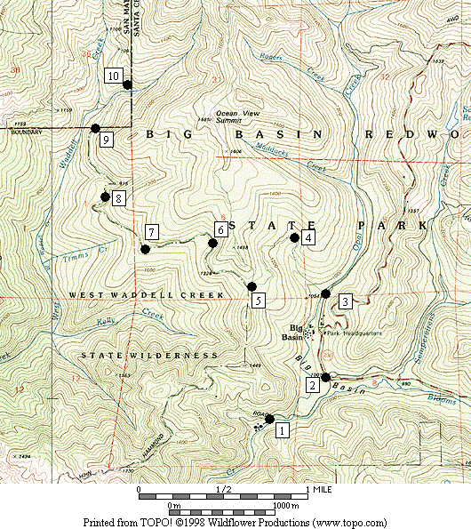

Figure 3-1. Stops on the Breeding Bird Survey route “Pescadero, CA” (#14-319) where Marbled Murrelets were detected on surveys in 1992-2009.

Figure 3-2. Marbled Murrelet activity recorded within Big Basin Redwoods State Park on the "Pescadero, CA” Breeding Bird Survey route in 1992 to 2009. (Note: No data for 2000; no detections in 2005.)

